**Machine Learning:**

**Machine Learning (ML)** is a field of computer science and a subset of **Artificial Intelligence (AI)** that focuses on developing systems that can **learn from data**, **identify patterns**, and **make decisions** with minimal human intervention.

**Another Definitions:**

Instead of being explicitly programmed with step-by-step instructions for every possible task, ML systems are **trained on data** and learn to perform tasks by recognizing patterns.

Machine learning is a subfield of [artificial intelligence](https://www.tutorialspoint.com/artificial_intelligence/index.htm) that enables machines to learn from data without being explicitly programmed.

As the name suggests, it refers to the capability of a machine to learn and exhibit "intelligent behavior" similar to that of humans. Machine learning uses data and algorithms to learn hidden patterns in the data and make predictions on new unseen data.

*Ever wondered how 'Amazon' accurately recommends something that you might like or that you are looking to purchase? Or how emails are filtered into primary, social and promotions? Well, thanks to Machine learning.*

**Example: Email Spam Filter**

Let’s say we want to build an ML model to filter spam emails:

1. **Data**: A large collection of emails, each labeled "spam" or "not spam".
2. **Features**: Presence of certain words (e.g., "free", "win", "urgent"), length of email, etc.
3. **Model**: Train a classification algorithm to learn patterns from the data.
4. **Prediction**: Given a new email, the model predicts whether it is spam.(test data/unseen data/new data.)

**Difference between AI,ML and DL** :

| **Concept** | **Description** | **Example** |
| --- | --- | --- |
| **AI (Artificial Intelligence)** | A broad field focused on creating intelligent machines. | Siri or Alexa (understands language, responds intelligently). |
| **ML (Machine Learning)** | A subset of AI that learns from data. | Netflix recommending shows based on your watch history. |
| **Deep Learning** | A subset of ML that uses neural networks to simulate human decision-making. | Self-driving cars recognizing pedestrians using image data. |

**Types of Machine Learning:**

1.[**Supervised Machine Learning (SVM)**](https://www.tutorialspoint.com/machine_learning/machine_learning_supervised.htm)**:** It is a type of machine learning that trains the model using **labeled datasets** to predict outcomes.

 The process is like a teacher guiding a student—hence the term "supervised" learning.

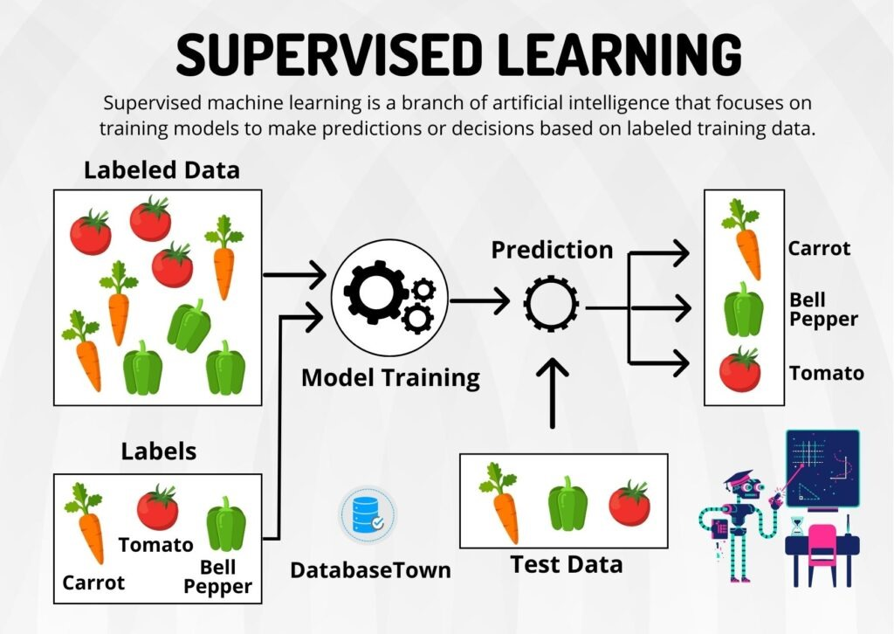

**2. Unsupervised Learning**

**🧠 Concept:**

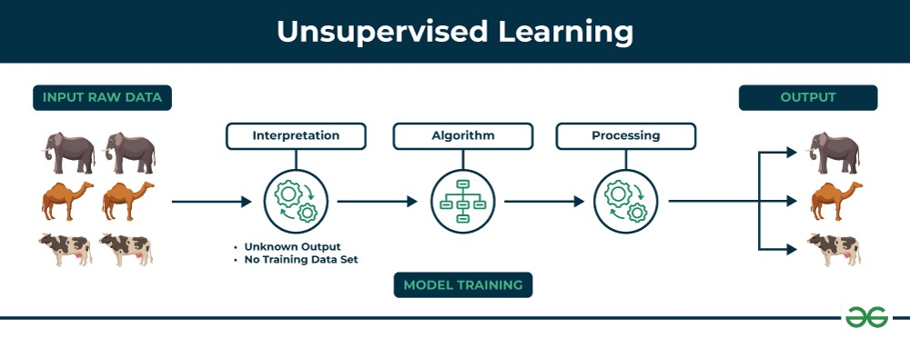In unsupervised learning, the model is **given input data without labeled outputs**. It tries to find **patterns or groupings** in the data.

Unsupervised Learning Doesn't Know "Cat" or "Dog"

In unsupervised learning, the model does not have labels (like “cat” or “dog”), so it cannot directly output those names.

🧠 So What Does It Output?

Instead of saying

"This is a cat" or "This is a dog"

It says something like:

"These images belong to Group A"

"These images belong to Group B"

Later, a human might look at Group A and realize it's mostly cats, and Group B is mostly dogs.

📦 Real-World Analogy

Imagine giving a child a box of mixed objects (without naming them) and asking them to sort by similarity. They might group:

All round things together (balls, oranges)

All flat things together (books, tablets)

They won’t say "ball" or "tablet" — but they’ll find structure. That’s what unsupervised learning does.

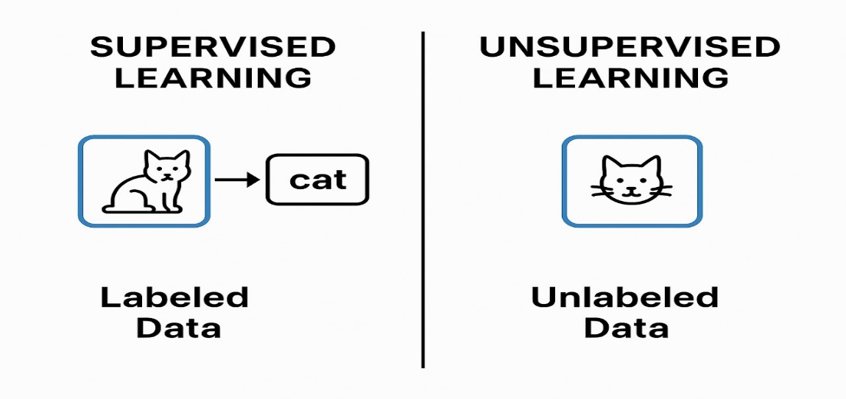

**3.Reinforcement Learning(RL):**

🎯 Definition:

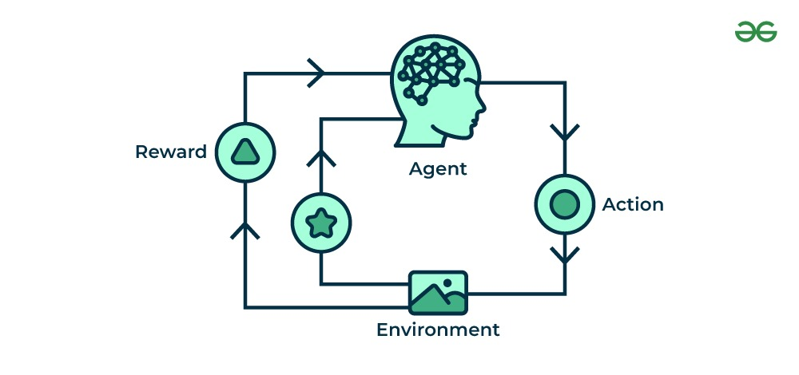Reinforcement learning is a type of learning where an agent learns to make decisions by interacting with an environment. It receives rewards or penalties based on its actions, and its goal is to maximize the total reward over time.

| Term | Meaning |
| --- | --- |
| Agent | The learner or decision maker (e.g., robot, AI player) |
| Environment | The world the agent interacts with (e.g., a game, a factory) |
| Action | What the agent chooses to do (e.g., move left, buy stock) |
| State | The current situation of the agent |
| Reward | Feedback from the environment (positive = good, negative = bad) |
| Policy | Strategy that the agent follows to decide what actions to take |
| Episode | One full run from start to end (like a single game play) |

🕹️ Simple Example: Video Game

1. Agent: A game-playing bot
2. Action: Move forward, jump, attack
3. Environment: The game world
4. Reward: +10 for defeating an enemy, -5 for falling into a trap
5. Goal: Learn the best strategy to win the game with maximum points(maximum reward.)

🤖 Real-World Applications:

* Robotics: Teaching a robot to walk or pick up objects
* Game AI: AlphaGo, AlphaZero by DeepMind
* Finance: Automated trading strategies
* Self-driving cars: Learning to navigate safely
* Recommendation systems: Learning what content to suggest based on user behavior

**4.semi-supervised machine learning**

Combination of supervised and unsupervised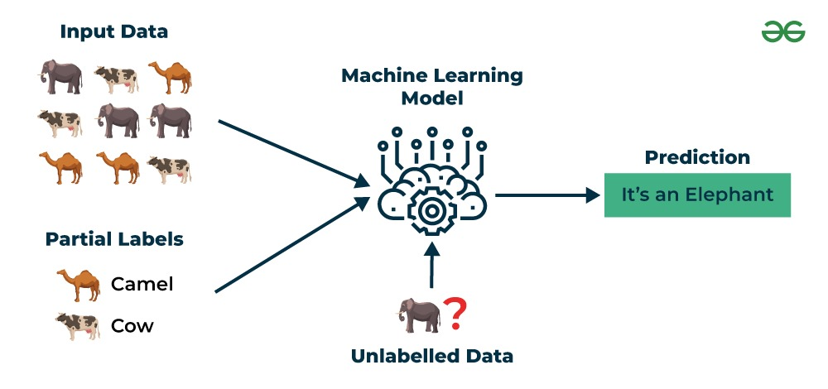

**Difference between supervised and unsupervised:**

| **Feature** | **Supervised Learning** | **Unsupervised Learning** |
| --- | --- | --- |
| Data Type | Labeled | Unlabeled |
| Output | Known (target variable provided) | Unknown (discover structure) |
| Goal | Predict outcomes | Find patterns or groupings |
| Example Tasks | Classification, regression | Clustering, dimensionality reduction |
| Typical Use Cases | Email filtering, speech recognition | Customer segmentation, anomaly detection |

| **Learning Type** | **Label Used in Training?** | **Output Example** |
| --- | --- | --- |
| Supervised Learning | Yes | "cat", "dog", "car" |
| Unsupervised Learning | No | Cluster 1, Cluster 2, Cluster 3 (no names) |

| **Question** | **Yes? → Use** |
| --- | --- |
| Do you have labeled data (inputs + known outputs)? | ✅ Supervised |
| Are you trying to **predict** or **classify** specific outcomes? | ✅ Supervised |
| Do you only have raw input data, with no labels? | ✅ Unsupervised |
| Are you trying to explore structure, patterns, or groupings? | ✅ Unsupervised |

**ML workflow:**

**1.data collection:** Gather relevant information(eg: emails).1000 mails

**2.Datapreprocessing:** clean, format and transform the data for model use.(empty ,null values)

**3.Model Building**: choose algorithm(ex:decision tree random forest,linear regresssion etc..)

**4.Training the model:** use dataset to help the model learn patterns.

**5.prediction:** Apply the trained model to new/test data.

**6. Evaluation:** Measure the model performance using metrics like accuracy or precision,recall,f1_recall.75% 0r 95%